Removing background with GIMP

Suppose you have an image you want to use in your program, but you only want the interesting part (like the adorable puppy in Figure 1), with the background removed and made transparent. This is important not just for slide presentations as in Chapter 2, but for arcade games as in Chapter 12. If the AI tools you find aren’t up to the task, here’s an easy Supway to make the background transparent and keep the pup. (I suggest you follow along using an image of your choosing. Pixabay.com is one great source.)

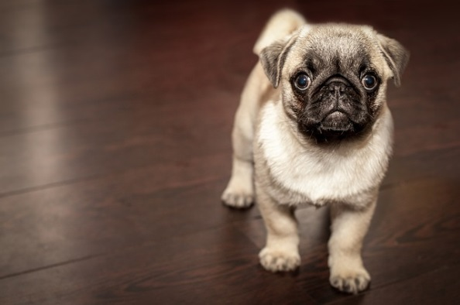

Figure 1. A JPG image, found in ch2/5-pupdog/media.of the code repository.

Be warned: unless you're a true artiste, the resulting image may look ragged around the edges.

Load your image in a deluxe graphics editor. I'll assume GIMP in my examples.

Next, tell GIMP you want to allow transparency. Under the Layer menu, select Transparency > Add Alpha Channel. What's an alpha channel? Alpha is how transparent a pixel is. Adding the channel means transparency is possible. Figure 2 shows how this might look.

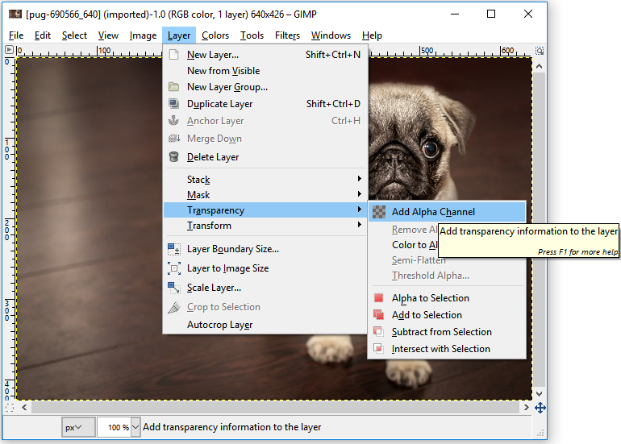

Figure 2. Adding transparency in GIMP.

Now we'll remove the background, leaving a transparent area instead. You'll need what GIMP calls the "Fuzzy Select Tool" (see Figure 3), which selects an area of similar colors (in this case, the colors in the floor). The tool looks like a fairy godmother's wand. Don't ask me how I know that.

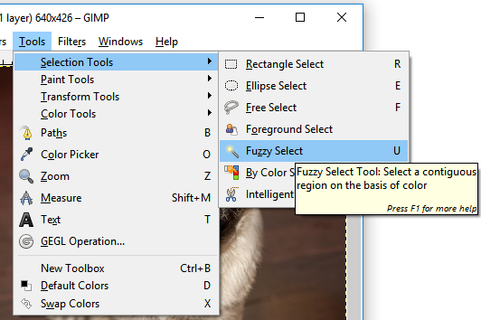

Figure 3. The Fuzzy Select Tool.

Click the wand on parts of the background and hit delete. (If you mess up, use Ctrl-Z to undo.) You should see a checkerboard pattern, which means you're seeing through the image to whatever's behind. You can also clean up with Rectangle Select, other Selects, or the Eraser; and, if you like, Crop to Selection, Scale Image, whatever. Figure 4 shows how it might look.

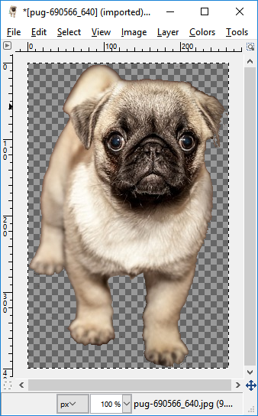

Figure 4. An image with transparent background. I also cropped it.

When you're done admiring your handiwork, save -- no, export[1] ‑- into PNG format, and use the result in your programs. Done!

1. Graphics editors don't let you *save* in useful formats; saving is for their own format. You have to *export* instead.